Green School Update
3/18/13

Four Objectives
1. Habitat Restoration
-- First garden workday was 3/9 – huge success.
-- Cleared spot for Monarch Waystation, removed invasives
-- Next work day is Sunday, 4/14
2. Outdoor Structures
-- “Kinder-Garden” Nature Trail cleared; getting ready for planting
3. Reduce/Reuse/Recycle
-- TFLD this Friday, once a month until the end of the year
-- Recycling signs and monitors in classrooms
-- Dotty/SCA initiative
4. Energy Conservation
-- “Power Down” guidelines distributed

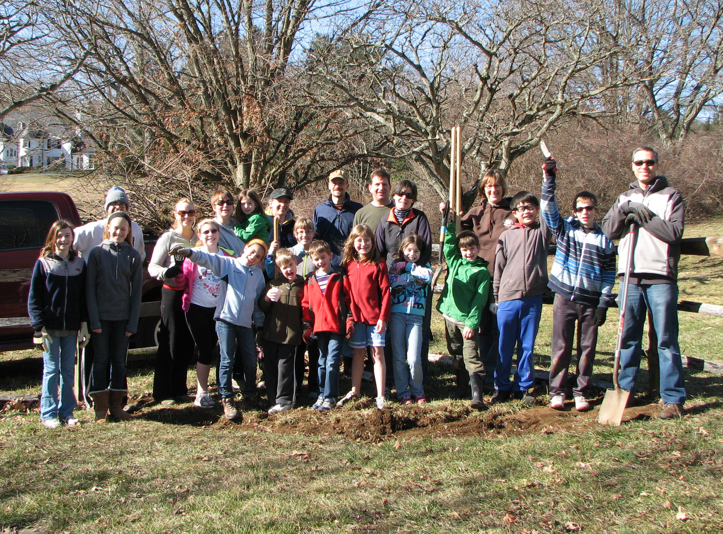

Curriculum – One quick walk-through of the school shows so much:
-- Kindergarten – bear unit enhanced using materials loaned by CVP
-- 1st grade – animal habitat mobiles
-- 1st grade – raised, tagged and released monarch butterflies
-- Art -- fairy houses using recycled materials
-- T. Lebedda’s 5th graders – volcano research and models
-- By L. Ashley’s room – worm research?
-- TV crew – interviewed a first grader from habitat clean-up; will start including environmental messages and vocab on announcements
-- Author visit this week – Environmental theme
-- 2nd grade (?) – wrote about using all their senses to describe “winter”

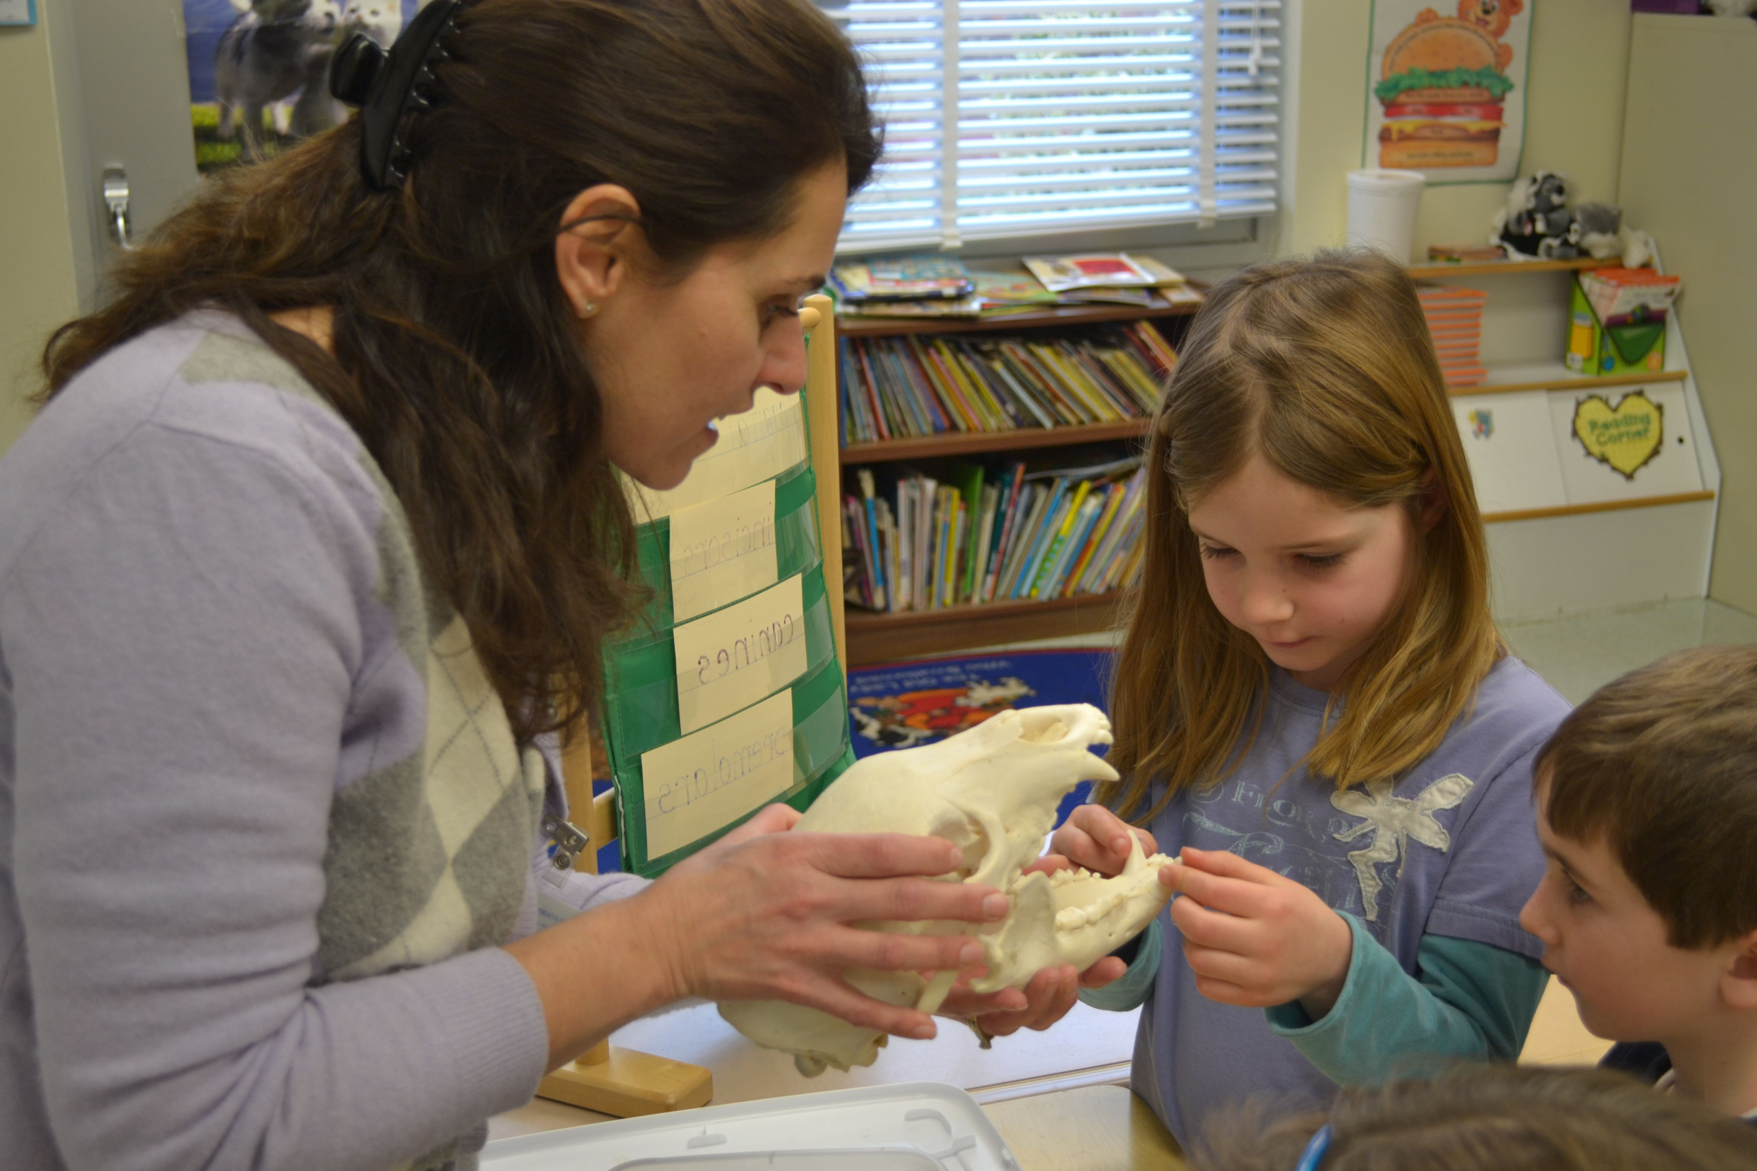

Celebration
-- New bulletin board
-- Earth Week activities this year – I’ll be in touch in grade-level chairs
-- Art Show 2014 will have “green theme”

Community Partnerships
CVP:
-- Continues to advise RW on schoolyard habitat
-- Taught 1st grade how to tag and release monarch butterflies for migration. Children recorded data for Monarch Watch program
-- Trained K teachers on “Growing Up Wild” curriculum and donated book to supplement existing unit on bears
-- Provided bearskin, skull, and tracks to K classes for bear unit
-- Developed Beaver Program for RW Girl Scout troops. Six troops signed up.

Pennington Seed Company
84 Lumber Company
Girl Scout Troops

Next Steps

1. Continue to send me grade-specific environmental activities using attached template OR track me down in the halls ☺

2. Professional Development ideas:
-- Attend MAEOE conference next Feb/other workshops or classes/continuing ed
-- Do volunteer work on environmental issues
-- Actively learn about the environment at CVP, Oregon Ridge, other parks
-- Contact me if your grade level in interested in a CVP training during your planning period

3. See you at the garden workday on 4/14! (1-4 pm)

